
Traditional Farming
/
6/2024
8

Kikuyu Traditional Farming and Cultivation Practices
Author
ALEX NGARI WERU

Preservation of Traditional Farming Practices in Kikuyu Culture

Preface
The Kikuyu also referred to as (Agikuyu/Gikuyu) are a Bantu ethnic group native to East Africa Central Kenya. It is currently the ethnic group in Kenya among 42 other ethnic groups, to have the largest population of 8,148,668 as of 2019 census, accounting for 17.13% of the total population in Kenya, making us Kenya’s largest ethnic group. (Kikuyu People - Wikipedia, n.d.)


Figure 1: Kikuyu Village Traditional Dancers
The Kikuyu belong to the Northeastern Bantu branch. Our language is most closely related to that of the Embu and Mbeere. Geographically we are mostly located in the slopes of Mt. Kenya.
There are different theories and beliefs about the origin of the Agikuyu. Speculations have it, our fore fathers originated from the Congo Zaire. According to some Kikuyu cultural teaching, we are a product of Gikuyu and Mumbi, who were our first parents; they were created by Ngai (God) who blessed them with nine daughters from whom the Kikuyu ethnic group was born. From archaeological evidence, their arrival at the northern side of Mt. Kenya dates to around the 3rd century, as part of the larger group known as Thagicu. By the 6th century, there was a community of Agikuyu newly established at Gatung'ang'a in Nyeri. The Agikuyu established themselves in their current homeland of Mt. Kenya region by the 13th century. (Kikuyu People - Wikipedia, n.d.)
After their arrival into their new modern territory, they still maintained their indigenous farming practices. Their traditional economy rested upon intensive hoe cultivation of millet (staple crop), peas, beans, sorghum and sweet potatoes. The main modern cash crop which would be introduced later after colonization are coffee, maize, wattle, fruits and vegetables. During the time, there was ample rain to grow their produce both for subsistence and commercial purposes; batter trade with other ethnic communities in the country. Animal husbandry also provided an important supplement.
The Kikuyu have numerous traditional activities that they practice. Among them included social, economic and political practices. In our discussion today, our focus will be directed to the economic practices that is farming and cultivation. (Kikuyu People - Wikipedia, n.d.)
Farming and cultivation is an economic activity that has been practiced from time in memorial by our fore fathers, and is still done currently. This included both crop and animal farming using traditional means and tools & equipment. Common traditional farming practices include agroforestry, intercropping, crop rotation, cover cropping, traditional organic composting, and integrated crop-animal farming. Farming methods include shifting cultivation, slash-and-burn farming etc. These practices carry both their merits and demerits which we will discuss later. In our case the merits outweigh the demerits. Though not in large scale, everyone in the community was involved in the farms.

Traditional Farming Practices by Kikuyu
Traditional agriculture is a primitive type of food production and farming that makes extensive use of indigenous knowledge, land use, traditional equipment, natural resources, organic fertilizer and farmers’ cultural values.
Kikuyu Traditional Crops:
i. Sweet potatoes, Yams, Arrow Roots, Cassava
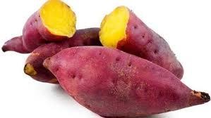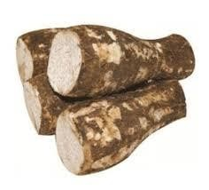

Figure 2: Traditional Kikuyu Yellow Sweet Potatoes (Ngwache) and Arrow Roots (Nduma)

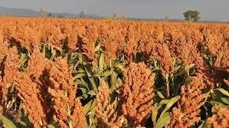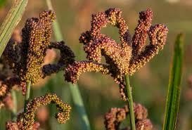
ii.

Millet and
Sorghum

Figure 3: Traditional Kikuyu Sorghum and Millet.

iii. Vegetables (pumpkin leaves)
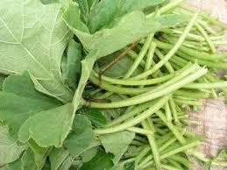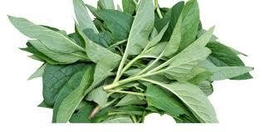

Figure 4: Traditional Kikuyu Pumpkin Leaves (Mabaki & Kanyuria).

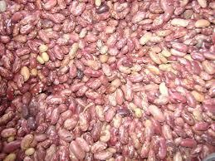
iv.

Beans and Peas

Figure 5: Traditional Kikuyu Beans (Njahi & Mbocho).

Modern
- Tea
- Rice
- Coffee iv. Maize
v. Irish Potatoes

Characteristics of Traditional Farming and Cultivation.
- Rooted in centuries-old practices and local knowledge.
- Emphasizes manual labor and simple tools.
- Often geared towards subsistence farming for local consumption. iv. Favors crop diversity and organic practices.
- Relies on preservation of indigenous seed varieties.
- Utilizes use of family or community labor.

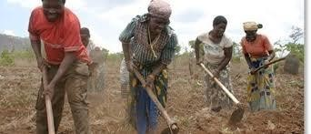

Figure
6
:

Traditional Communal Cultivation.

Merits
- Low environmental impact due to inorganic practices.
- Relies on natural pests control and crop rotation to maintain soil fertility. iii. Preserves biodiversity through diverse crops and native seeds.
- Suitable for small scale farmers and needs.
- Well suited for maintaining traditional cultures and local ecosystems. vi. Promotes sustainability through organic practices and community reliance.

Demerits
- Generally lower productivity compared to modern farming.
- Unsuitable for large scale farming.

Tools and Equipment Used

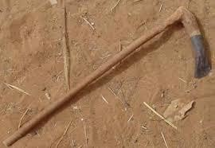

Figure
7
:
Traditional

Digging Hoe.



Figure 8: Traditional Digging Stick
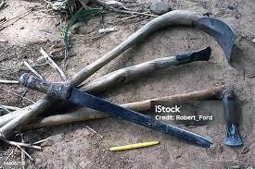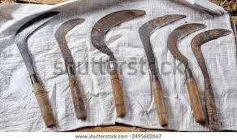

Figure
9
:
Traditional Farming and
Cultivation Tools

Figure 10: Traditional Farming & Cultivation Pangas and Machetes.

Methods and Practices of Traditional Farming.

Shifting Cultivation & Bush Fallowing
This practice is also referred to as slash and burn cultivation. It encompasses the practice of growing crops on a land covered with ashes produced from burning piles of wood and other cut vegetation. The burning process is carried out before the onset of the rainy season in order to destroy pests and add fertility to the land with ash. (Hamadani et al., 2021)
When the soil shows sign of exhaustion, the land is left uncultivated and allowed to regain its fertility and productivity and the vegetation grows again and till then the farmers would move to another plot.
They would cultivate the cleared plot for 2-3 years and then left fallow for approximately 10-20 years. This practice was achievable due to the adequacy of land putting into consideration that the land during that time was communally owned. (Hamadani et al., 2021)

Demerits
- The sustainability of this system relied on the length of fallow period. Shorter periods may not allow replenishment of nutrients and longer periods may lead to runoff and soil loss.
- Large amounts of fuel would intensify the fire and cause damage to the top layer of the soil.
- Implications on the environment caused by deforestation and air pollution due to clearing and burning of the vegetation. (Hamadani et al., 2021)

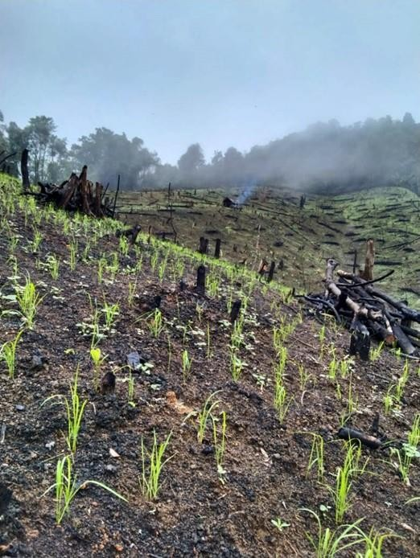

Figure
11
:
Traditional
Shifting Cultivation.

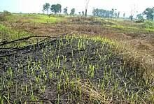 Figure 12: Traditional Shifting / Fallow Cultivation.

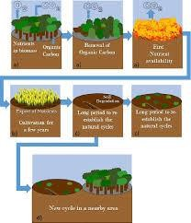
Figure 13: Stages of Shifting Cultivation.

Others
Agro Forestry:
It is an age-old practice dating back to the beginning of farming and animal husbandry, it involves the practice of planting trees along with crops. It has potential for mitigation of the effects of climate change, adaptation, food security, and crop productivity. (Hamadani et al., 2021)
The practice played a big role in improving soil quality, water retention, carbon sequestration, agro-biodiversity and ultimate farmers’ income through batter trade. It was very crucial especially in drought-seasons areas owing to the fact that the deep roots of trees explore a larger soil volume for water and nutrients. Also known as silvopastoral system since it is beneficial to livestock trough production of legumes and fodder grown together with the trees. (Hamadani et al., 2021)
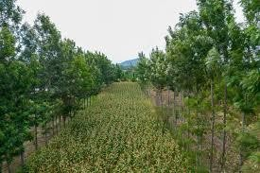

Figure 14: Traditional Agroforestry.

Intercropping
The practice of cultivating more than on crop species on the same field. The ancient people considered it to be a highly productive farming system, which utilizes the natural resources such as land, water and nutrients, efficiently and increases productivity, biodiversity, resilience and stability of the agroecosystem. (Hamadani et al., 2021)
Since more than one crop is being used and different crops have different adaptability, this practice reduces climate –driven crop failure. Our forefathers practiced this especially in cultivation of beans and sorghum. This helped reduce soil erosion as well as add benefits to the system.
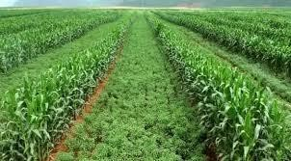

Figure
15
:
Traditional Intercropping

Crop Rotation
A traditional practice of growing a sequence of crops on a given land area every growing or planting cycle and season. It includes benefits like improvement of soil quality and fertility, carbon sequestration, increased yields, effective water utilization, reduced soil erosion and nutrient recycling. Use of leguminous crops reduce dependence on external source of nitrogen fertilizers. (Hamadani et al., 2021)

Cover Cropping
Traditional practice of cultivating a crop in order to cover the land to reduce rate of soil erosion and loss of soil nutrients. Both leguminous and non-leguminous crops were used; they were generally harvested before the plantation of the main crop or even alongside the main crop.
Helped in weed control, water storage, soil health maintenance, improvement of soil microbial biomass and carbon sequestration. (Hamadani et al., 2021)
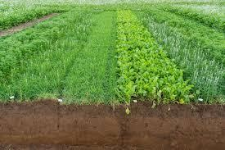

Figure
16
:
Traditional Cover Cropping.

Composting
It was a practice of decomposing organic matter by micro-organisms under controlled conditions to produce compost manure used in the farms. This organic manure was used to enhance soil fertility. Ancient people used different materials to make it including; kitchen refuse, FYM (Farm Yard Manure), crop residues, ash, soil etc.
It helped improve soil aeration, reduce green-house gas, increase soil microbial activities, soil moisture, soil fertility, reduce soil erosion, control pests and diseases. Generally adaptation of such a practice helped maintain a safe environment. (Hamadani et al., 2021)
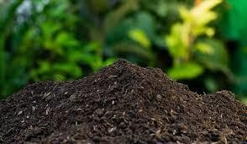

Figure 17: Traditional Compost Manure.

Conclusion
The Kikuyu fore parents set an example of inventing and continued use of a practice that would be used not only by them but rather also by many generations later. Clearly, most of these practices are being used today, which is quite helpful and beneficial to many farmers. These practices have been ever-evolving since their invention. Tremendous population expansion, shrinkage of resources, changes in mind set, and invention of new technologies and tools with passing time have all contributed to this. However, indigenous knowledge passed on through generations from our ancestors is still being used to date and it comes with its own merits as I mentioned earlier. Particularly, most of these practices have been in tune with the environment and being less resource intensive. Such farming practices are gaining attention as the world is looking for new alternatives to our production system, while facing serious challenges such as climate change, biological magnification, and environmental degradation

References
Kikuyu people—Wikipedia. (n.d.). Retrieved August 6, 2024, from https://en.wikipedia.org/wiki/Kikuyu_people
Hamadani, H., Mudasir Rashid, S., Parrah, J., Khan, A., Dar, K., Ganie, A., Gazal, A., Dar, R., & Ali, A. (2021). Traditional Farming Practices and Its Consequences (pp. 119–128). https://doi.org/10.1007/978-3-030-61010-4_6

